Gaussian Elimination Program Execution Proof

User-Defined Generalized Python Program

Execution Evidence
The following screenshots provide proof of successful execution of the Gaussian Elimination program in the Jupyter notebook.

1. User Input
The program accepts a 4 × 4 coefficient matrix and the corresponding RHS vector from the user.

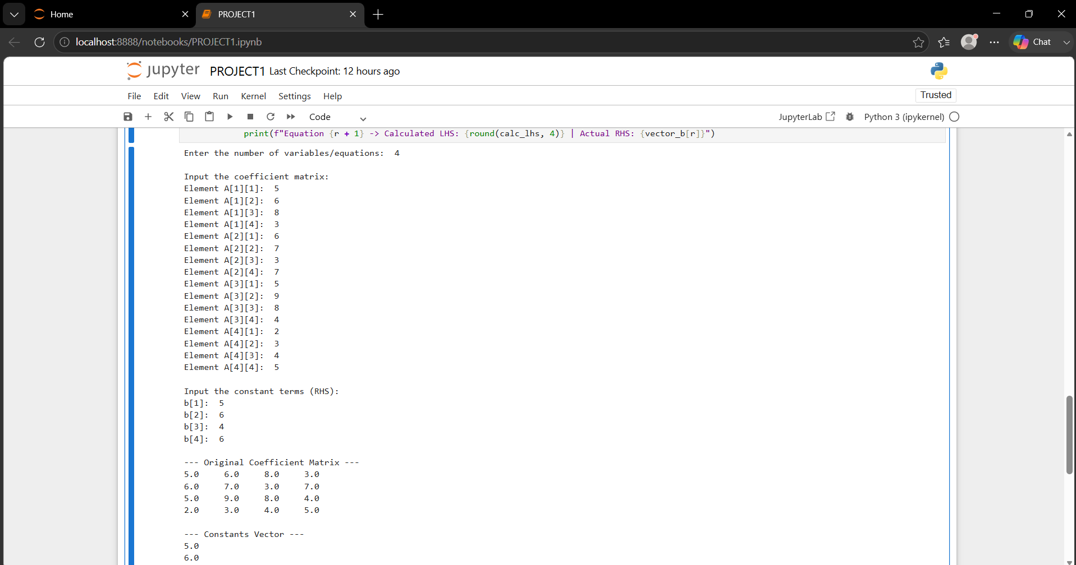Figure 1: User-defined input and program execution.

2. Program Output and Verification
The output shows the coefficient matrix, RHS vector, augmented matrix, matrix after forward elimination, solution obtained using back substitution, and verification of the solution.

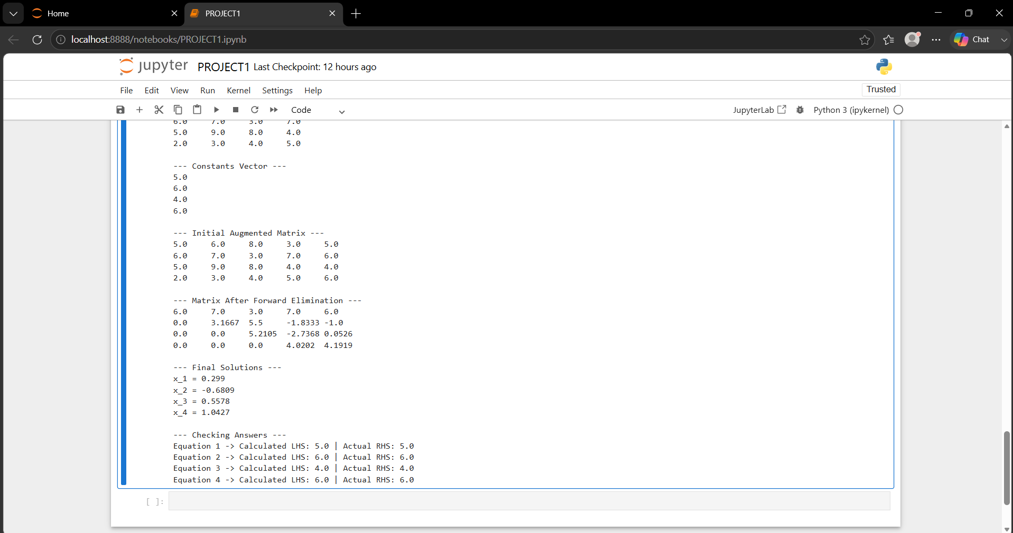
Figure 2: Successful Gaussian Elimination output and solution verification.
Observed Result
Solution obtained:
x₁ = 0.299
x₂ = -0.6809
x₃ = 0.5578
x₄=1.0427
Verification confirms that the calculated Left-Hand Side (LHS) is equal to the corresponding Right-Hand Side (RHS) for all three equations, demonstrating successful execution of the program.

